**Conservation Desktop Nutrient Sensitive Area Analysis- BR**

## Purpose:

Develop methodology and tools to enable conservation planners ability to view via map and quantify with reporting methods the sensitive areas related to nutrient issues within an land unit. Conservation Planners will have the ability to identify a practice schedule that will be used to consolidate a list of land units that will be analyzed during this process. Results will be stored for future use within the CART assessment and ranking process. Conservation Products module will have the capability to retrieve the generated information and development of a map and report to provide the planner and client necessary information for planning practices.

## Scope:

* Development of intersect analysis tool that will analyze all land units associated with a practice schedule with the Nutrients SVI geospatial service currently in Geoportal.
* Development of a georeferenced image file that is associated to the practice schedule that can be opened in the map view and also be used to create a hard copy map in the conservation products module
* Development of Database tables to store results on a land unit bases for a practice schedule’s land units. (We need to know how this will be used for ranking in order to design the tables for storing the information. Summarization of total application area vs land unit ranking?)
* Development of summarization report and map utilizing the generated georeferenced image file in the conservation products module

Business Rules

1. All land units in the practice schedule that have a land use of “Crop” will be the input for intersection with the Nutrients SVI layer. Other land uses will not participate in the analysis as they are not valid for this analysis
2. Intersect analysis data will be stored by land unit and planned system id. Creation date will be acquired for the analysis in order to compare the creation date of the analysis with land unit modification dates to determine if the analysis is still valid.
3. System will not enable the Pre-Planning Analysis button in the practice schedule panel if there are no land units associated to the practice schedule.
4. Layer name in map contents for the intersected layers will be “Nutrient Sensitive Areas”

Use Case 1: Nutrient Sensitive Area Intersect

1. User opens a practice schedule that has land units associated with the practice schedule with at least one land unit being attributed with a land use of “Crop”.
2. User clicks on the Pre-Planning Analysis button in the practice schedule panel of the Table of Contents.
3. System opens Pre-Planning Analysis UI
4. In the Pre-Planning Analysis drop down user selects Nutrient Sensitive Areas option.
5. User clicks on the Create button.
6. System checks current land units to ensure at least one land unit has a land use of “Crop”.
7. If no land units meet the criteria then the system will return a message “There are no cropland land units associated to the schedule, at least one cropland land unit must reside in the schedule for the analysis to be completed”.
8. If at least one land unit has a land use of “Crop” then system intersects the land units with a “Crop” land use with the Nutrients SVI layer.
9. System creates a georeferenced image file from the intersect analysis and saves it to the appropriate tables in NPAD
10. System writes the appropriate information by land unit to the tables in NPAD.
11. System updates map contents with the georeferenced image file as a layer named “Nutrient Sensitive Areas” in map contents. (This should be similar to how the soil inventory and report tool works.)
12. System turns the Nutrient Sensitive Areas layer to feature visible and refreshes the map.

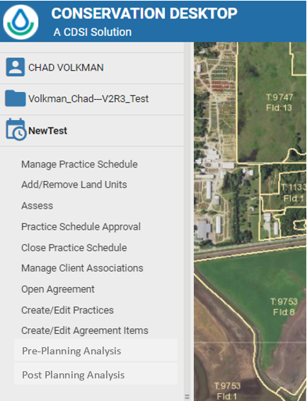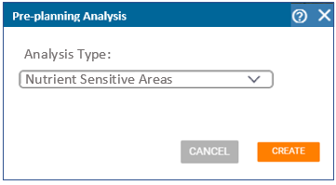

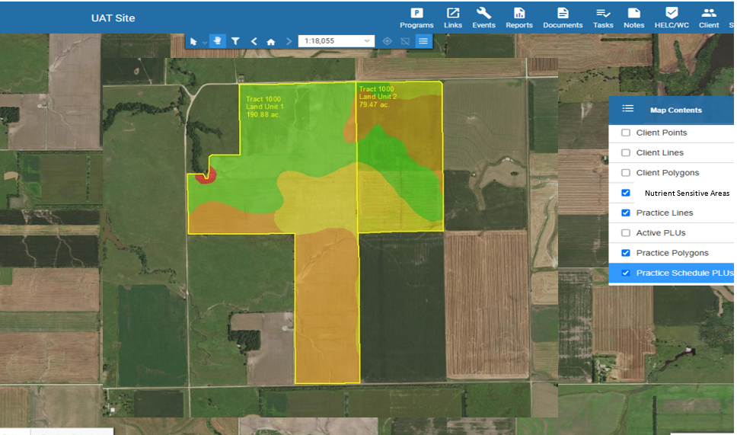Use Case 2: Conservation Products Nutrient Sensitive Areas Map and Report

1. User clicks on the Conservation Products button under the Case file panel in the Table of Contents
2. System opens the Conservation Products Dialog.
3. User selects Inventory and Assessment from the Production Category drop down
4. System verifies the existence of a valid Nutrient Sensitive Areas analysis associated to the currently opened practice schedule. This step relates to business rule 2 listed above.
5. System populates the drop down with an option “Nutrient Sensitive Areas Map and Report” if there is a valid analysis associated with the practice schedule.
6. User selects “Nutrient Sensitive Areas Map and Report” from the Product Type drop down.
7. User selects Next.
8. User selects map headings for the map (Map title will default to Nutrient Sensitive Areas)
9. User selects Next
10. System displays the Layout and Scale options
11. User selects pages size, map scale and has the option to create a Geospatial PDF.
12. User clicks Next
13. User clicks the Create option
14. System displays option to enter a file name for the map and report
15. User enters name and clicks Create
16. System creates a .pdf file that contains the map on one page of the .pdf and a report on the subsequent pages of the .pdf.
17. System displays conservation products table with the .pdf file being created listed as with the same options available to other conservation product .pdf files in the table.

